Prediction of Lung and Colon Cancer using Bayesian Optimization based Deep Learning Model
¹, ², Dr.J.Avanija³, Tatireddy Nandeeswar Reddy⁴, ⁵, Dr.K.Reddy Madhavi⁶
¹CMR Technical Campus, Hyderabad, Telangana, India
^{3,6}Professor, Department of AI&ML,School of Computing, Mohan Babu University, Tirupati, AP, India
²CMR Technical Campus, Hyderabad, Telangana, India
⁴UG Scholar, Department of AI&ML,School of Computing, Mohan Babu University, Tirupati, AP, India
⁵CMR Technical Campus, Hyderabad, Telangana, India

^{1, 2, 3}avans75@yahoo.co.in,
⁴nandeswar71@gmail.com, ⁵, ⁶kreddymadhavi@gmail.com
Abstract. Precise and well-timed diagnosis of the fatal types of cancers such as lung and colon cancers plays a crucial role to advance patient outcome and decreasing death rates. With the upcoming display of Machine Learning techniques, there is an unexpected opportunity to improve the diagnostic accuracy and successfulness of cancer prediction from medical imaging. The proposed work utilizes Bayesian Optimization based deep learning model (BO-DL) using Convolutional Neural Network in lung and colon cancer diagnosis using histopathological images as input. The proposed method is compared with existing methods using various performance metrics. Results reveal that the accuracy of diagnosis for lung and colon cancer is better compared to existing methods.
Keywords : Disease Diagnosis, Activation Function: Rectified Linear unit (ReLu), Convolutional Neural Networks, Histopathological Images
- Introduction
The major contributors of deaths due to cancer are lung and colon cancers, necessitating early diagnosis and facilitating treatment to improve patient lifespan. Traditional methods of diagnosis do exist and more fruitful too, but, one can’t detect the disease early unless integrating the Machine Learning (ML) and Deep Learning (DL) methodologies with medical imaging offers very good and accurate diagnosis.
In recent times, evaluation of the medical imaging with Deep Learning (DL) techniques has increased in various sectors of medical imaging that can improve the diagnostics accuracy for various cancers. The methodologies enable the extraction of the histopathological image patterns, crucial in detecting the cancer tissues at early stages. CNNs are simply go-to Deep Learning (DL) approaches which has high success rate in learning hierarchical features and analyzing the complex data. The existing system has an accuracy of 96%.
- Background Work
The background work discusses multiple ML methodologies and two DL methodologies to diagnose brain tumor from MRI images exploring their use in medical diagnosis and disease sorting. It also discuses breast cancer identification accuracy, bone cancer detection, and a patch-based DL method for breast cancer classification [1-5]. A study conducted at Leipzig University Hospital applied machine learning methodologies to diagnose colorectal cancer and esophagogastric cancer revealing high values for ROC and low standard deviation. The study also inspected the accuracy of prediction utilizing transfer learning techniques in medical image analysis and focusing the capacity of artificial intelligence in early diagnosis and survival rates [6-10]. Artificial Intelligence and Deep learning methods are important in healthcare for image processing disease detection and patient treatment. They enhance patient outcomes and decrease the burden on healthcare workers. Deep neural networks increase techniques for early diagnosis of diseases like colorectal cancer, improving the quality of colonoscopy and preventing cancer [11-15]. A new breast cancer model using deep learning enabled capsule network is introduced that reached higher accuracy of 98.50 and 97.55 on DDSM and Mini-MIAS datasets. A multimodal based classification method using sparse representation for lung needle biopsy images is also presented, a fog computing system for lung cancer nodule detection and an automated method for diagnosing myocardial infraction [16-19].
- Methodology
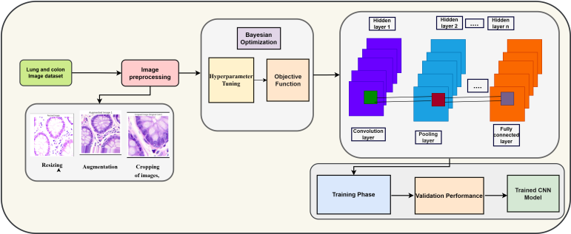
This section, discusses about the steps of the BO-DL model to perform medical image analysis. The steps for the proposed model for performing the analysis have been mentioned in figure 1. The initial step is to collect dataset containing medical image samples to carry out analysis.
Fig. 1. Disease diagnosis for medical images framework using CNN architecture

The proposed work uses Lung and Colon Cancer Histopathological Images dataset from kaggle for processing. The architecture of the proposed work is specified in figure 1.
  - Image Preprocessing
The next step is image preprocessing which includes resizing, augmentation, cropping of images, edge detection and denoising images. This process begins by setting up of image dimension,where ‘M’ denote the number of rows and ‘N’ denote the number of columns of the image. Let ‘p’ denote the size of each patch and ‘o’ denote the overlap between patches. The output of this step is to obtain clear and denoised Image to improve accuracy. Then,extract patches from the image using slicing as specified in equation 1.
$patch=image[i:i + P, j:j + P]$ (1)
where ‘i’ ranges from ‘O’ to ‘M - P’ with step ‘P - O’, and ‘j’ ranges from ‘O’ to ‘M - P’ with step ‘P - O’.The number of patches extracted depends on how many iterations of ‘i’ and ‘j’ fit within the image dimensions, taking into account the patch size and overlap. Mathematically, the number of patches extracted can be estimated as specified in equation 2.
$Number of patches = \left(\left[\frac{M-P}{P-O}\right]+1\right) × \left(\left[\frac{N-P}{P-O}\right]+1\right)$ (2)
where:$\left[x\right]$denotes the floor function, which gives the value of the largest integer less than or equal to x. M - P and N - P ensure that patches extracted fit within the image boundaries without exceeding them. Calculation of weights is performed using equation 3 if the values of I and j are same.
$weights\left[i,j\right]=1.0$ (3)
If the values of I and j are not same compute the average intensity difference between patches $P_{i}$ and $P_{j}$as specified in equation 4.
$avg_intensity_diff =\frac{1}{n}\sum_{k=1}^{n}{}\left|P_{i}\left[k\right]-P_{j}\left[k\right]\right|$ (4)
where $n$ is the number of elements (pixels) in the patch. Computation of weights are performed using equation 5. The computer weights are assigned as specified in equations 6 and 7.
$\left\{\frac{\frac{1.0}{avg_{intensity}, }}{0,}\right. {}_{if avg_intensity_diff=0}^{if avg_intensity_diff≠0}{}$ (5)
$weights\left[i,j\right]=weight$ (6)
$weights\left[j,i\right]=weight$ (7)
The next step is to process the Bayesian Optimization(BO) algorithm. First, we need to define the hyperparameter, objective function to set up the BO. Identifying the learning rate, number of convolution layers, no of fillers in each layer, dropout rate and batch size this is used to define the hyperparameter. To identify the objective function we need to maximize the accuracy of CNN in validation test then set a hyperparameter and find the accuracy F1-score, recall and precision.
  - Model Architecture
The proposed CNN architecture helps in colon cancer detection from histopathological images. CNN is used to image analysis tasks. They will learn from raw pixel data and they will capture complex spatial patterns in medical imaging. Convolutional Neural Network(CNN) and is mainly used for medical images due to its automatically learn hierarchical features from image data. It has pre-trained CNN architectures like ResNet which have been trained on large-scale image dataset like ImageNet. This CNN experimenting with different network architectures which includes convolution, filter, pooling and fully connected layers.
For each ‘conv2D’ layer the input is batch size, channels, width and height. The number of filters specified as F and represented as kxk matrix where k represents the kernel size. The output shape $O$ of a convolutional layer is calculated as specified in equation 8.
$O=\left[\frac{H-K+2×padding}{stride}\right]+1$ (8)
where $H$ is the height (or width) of the input tensor. Each maxpooling layer considers the pooling window of size (P, P)’. The output shape o is computed using equation 9.
$O=\left[\frac{H}{P}\right]$ (9)
The operation of flatten layer is to convert a 3D tensor into a 1D tensor. The dense layer considers the number of neurons N from previous layer. The operation of the dense layer is specified in equation 10.
$Output=Activation (Input×Weights+Bias)$ (10)
where ‘Weights’ is a matrix of shape ‘(M,)’. The softmax activation function is applied for the final classification task. The number of classes is represented by M along with bach size. Each element represents the probability of the corresponding class.The softmax function is applied element-wise as represented in equation 11.
$softmax\left(x_{i}\right)=\frac{e^{xi}}{\sum_{j=1}^{M}{}{exj}^{}}$ (11
The categorical cross-entropy loss L is computed as specified in equation 12.
$L=-\frac{1}{N}\sum_{i=1}^{N}{}\sum_{j=1}^{M}{}y_{ij}log\left(P_{ij}\right)$ (12)
where N is the batch size, M is the number of classes,$y_{ij}$ is the true label either or 1), and $P_{ij}$ is the predicted probability for class j.
- Result and Discussions
The dataset used in the proposed approach is Lung and Colon Cancer Histopathological Images dataset from kaggle. This dataset contains 25000 histopathological images with 5 classes that includes lung benign tissue, adenocarcinoma, squamous cell carcinoma for lung and adenocarcinoma, benign tissue for colon cancer. These images were created from an original sample of HIPAA(Health Insurance Portability and Accountability) compliant and validated sources, they were expanded to 25000 using the Augmentor package. This dataset is commonly used to perform research related to lung and colon cancer, deep learning and medical image analysis. The sample histopathological images of used as input by the proposed model is specified in figure 2.

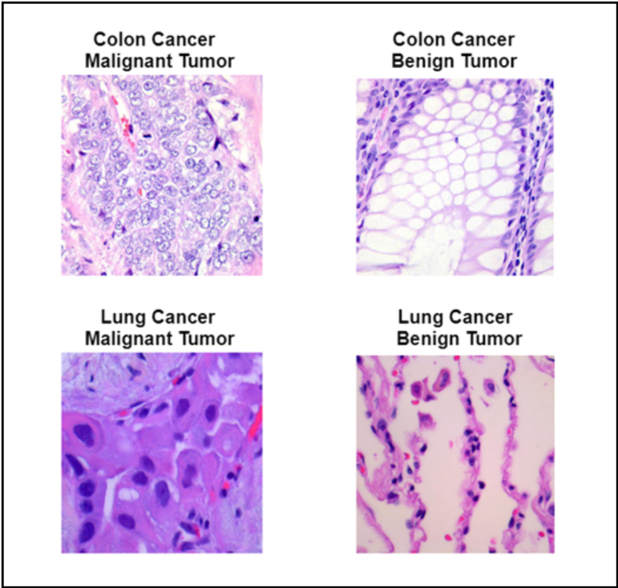

Fig. 2. Sample histopathological images from input dataset
The proposed CNN code is implemented in python for deep learning utilizing tensor flow and keras to train CNN on image data. It uses image data generator for data augmentation and flow from data frame for training, validation and testing dataset. The sequential keras model consists of multiple CNN and pooling layers fitting the model on the training data and validating it on validation data is how the model is trained.

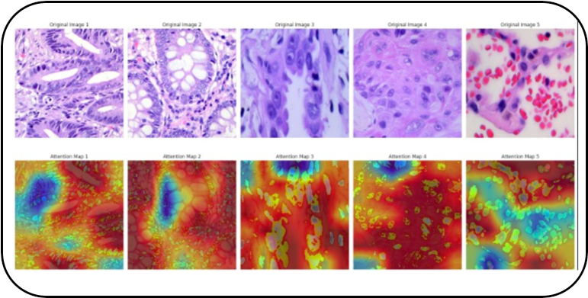
The proposed model has been evaluated using performance metrics such as precision, recall and F1-score. The evaluation results of the proposed model is represented in table 1. Results reveal that the proposed approach performs well with the accuracy of 98.6%. The generated predictions of the proposed model are specified in Figure 3.
Fig. 3. Generated Predictions by CNN Model
Table 1. : Evaluation of CNN method for disease diagnosis from medical images
Method | Accuracy | Precision | Recall | F1-Score
BO-DL (Proposed) | 98.6 | 0.90 | 0.82 | 0.82
Pyramid ViT | 91 | 0.89 | 0.79 | 0.80
SVM | 93.2 | 0.90 | 0.80 | 0.81

The hyperparameters and the optimized values of the hyperparameters generated by the proposed model is specified in table 2.
Table 2. : Hyperparameter tuning values for CNN approach
Hyperparameter | Best Value | Hyperparameter | Best Value
Learning Rate | 0.001 | Kernel Size | (3.3)
Batch Size | 64 | Output Layer | 5
Number of Epochs | 15 | Dense Layer | 2 dense layers with 256 and 128 units
Dropout Rate | 0.5 | Input Shape | 224,224,3
Activation function | ReLU (softmax) | Pooling type and size | (2,2)

5 Conclusion
The proposed Bo-DL based method utilized histopathological images to predict lung and colon cancer with the best accuracy of 98.6%. The proposed method uses CNN for training, splitting the dataset as training and testing data considering cancerous and non-cancerous tissues. This model serves as an important tool for lung and colon cancer prediction. Considering future challenges in healthcare sector future work focuses on working with complex deep learning techniques including other types of medical images, such as MRI, CT scans, and X-rays.By continuously evolving the proposed framework, we aspire to make a significant impact on early cancer detection and improve patient outcomes.

6 References
- Saeedi, S., Rezayi, S., Keshavarz, H., & R. Niakan Kalhori, S. (2023). MRI-based brain tumor detection using convolutional deep learning methods and chosen machine learning techniques. BMC Medical Informatics and Decision Making, 23(1), 16.
- Rana, M., & Bhushan, M. (2023). Machine learning and deep learning approach for medical image analysis: diagnosis to detection. Multimedia Tools and Applications, 82(17), 26731-26769.
- Safdar S, Rizwan M, Gadekallu TR, Javed AR, Rahmani MKI, Jawad K, Bhatia S. Bio-Imaging-Based Machine Learning Algorithm for Breast Cancer Detection. Diagnostics. 2022; 12(5):1134.
- Sharma, A., Yadav, D. P., Garg, H., Kumar, M., Sharma, B., & Koundal, D. (2021). Bone cancer detection using feature extraction based machine learning model. Computational and Mathematical Methods in Medicine, 2021.
- Hirra, I., Ahmad, M., Hussain, A., Ashraf, M. U., Saeed, I. A., Qadri, S. F., ... & Alfakeeh, A. S. (2021). Breast cancer classification from histopathological images using patch-based deep learning modeling. IEEE Access, 9, 24273-24287.
- Rana, M., & Bhushan, M. (2023). Machine learning and deep learning approach for medical image analysis: diagnosis to detection. Multimedia Tools and Applications, 82(17), 26731-26769.
- Safdar S, Rizwan M, Gadekallu TR, Javed AR, Rahmani MKI, Jawad K, Bhatia S. Bio-Imaging-Based Machine Learning Algorithm for Breast Cancer Detection. Diagnostics. 2022; 12(5):1134.
- Sharma, A., Yadav, D. P., Garg, H., Kumar, M., Sharma, B., & Koundal, D. (2021). Bone cancer detection using feature extraction based machine learning model. Computational and Mathematical Methods in Medicine, 2021.
- Hirra, I., Ahmad, M., Hussain, A., Ashraf, M. U., Saeed, I. A., Qadri, S. F., ... & Alfakeeh, A. S. (2021). Breast cancer classification from histopathological images using patch-based deep learning modeling. IEEE Access, 9, 24273-24287.
- Collins T, Maktabi M, Barberio M, Bencteux V, Jansen-Winkeln B, Chalopin C, Marescaux J, Hostettler A, Diana M, Gockel I. Automatic Recognition of Colon and Esophagogastric Cancer with Machine Learning and Hyperspectral Imaging. Diagnostics. 2021; 11(10):1810.
- Malik, H., Farooq, M. S., Khelifi, A., Abid, A., Qureshi, J. N., & Hussain, M. (2020). A comparison of transfer learning performance versus health experts in disease diagnosis from medical imaging. IEEE Access, 8, 139367-139386.
- Masud, M., Sikder, N., Nahid, A. A., Bairagi, A. K., & AlZain, M. A. (2021). A machine learning approach to diagnosing lung and colon cancer using a deep learning-based classification framework. Sensors, 21(3), 748.
- A. S. Panayides et al., "AI in Medical Imaging Informatics: Current Challenges and Future Directions," in IEEE Journal of Biomedical and Health Informatics, vol. 24, no. 7, pp. 1837-1857, July 2020,
- Yadav, Samir S., and Shivajirao M. Jadhav. "Deep convolutional neural network based medical image classification for disease diagnosis." Journal of Big data 6.1 (2019): 1-18.
- Mijwil, M., Al-Mistarehi, A. H., Abotaleb, M., El-kenawy, E. S. M., Ibrahim, A., Abdelhamid, A. A., & Eid, M. M. (2023). From Pixels to Diagnoses: Deep Learning's Impact on Medical Image Processing-A Survey. Wasit Journal of Computer and Mathematics Science, 2(3), 9-15. https://doi.org/10.31185/wjcms.178
- Kumar, Y., Koul, A., Singla, R., & Ijaz, M. F. (2023). Artificial intelligence in disease diagnosis: a systematic literature review, synthesizing framework and future research agenda. Journal of ambient intelligence and humanized computing, 14(7), 8459-8486.
- Sanchez-Peralta, L. F., Bote-Curiel, L., Picon, A., Sanchez-Margallo, F. M., & Pagador, J. B. (2020). Deep learning to find colorectal polyps in colonoscopy: A systematic literature review. Artificial intelligence in medicine, 108, 101923.
- Schmidhuber, J. (2015). Deep learning in neural networks: An overview. Neural networks, 61, 85-117.Deep learning in neural networks: An overview - ScienceDirectGet rights and content
- Thawani, R., McLane, M., Beig, N., Ghose, S., Prasanna, P., Velcheti, V., & Madabhushi, A. (2018). Radiomics and radiogenomics in lung cancer: a review for the clinician. Lung cancer, 115, 34-41. Radiomics and radiogenomics in lung cancer: A review for the clinician - ScienceDirect.

